
ذ
REPUBLIC OF YEMEN
SANA'A UNIVERSITY
FACULTY OF ENGINEERING
MECHATRONICS ENGINEERING DEPARTMENT



[PLC Ladder Logic program
for an electro-pneumatic ].

Done by:
Hassan Moqbel Morshed Ghaleb 202274198
Mousa Ali AL_salmani 202174202
System(Parallel)
Supervised by:
ENG. Mohammed AL_Maswary

contact:
Abstract............................ 1
Objectives…………............. ……… 2
Introduction………….......... …………….. 3
Theory.................................................. 4
Methodology………………………...... …... 5
The equipment……………………….... 6
Procedure…………………………… 7
Results……………………………8
Discusion…………………9
Conculosion…… 10
References……

#_ Abstract:-
This automation studio project involved developing PLC ladder logic programs to control an electro-pneumatic system. The system consisted of pneumatic cylinders, solenoid valves, pressure sensors, and limit switches. A programmable logic controller (PLC) was used to control the operation of the system based on input signals from sensors and operator controls.

The first step was to understand the functional requirements and design of the electro-pneumatic system. Input and output devices were mapped and the sequences of operations were analyzed. A ladder logic program was then designed in the automation studio software to implement the required control functions. The program incorporated normally open and normally closed contacts, timers, and counters to control the actuation of solenoid valves based on sensor feedback.

The ladder logic was developed, tested, and debugged using simulations in the software environment. Special attention was paid to issues like race conditions, indexing, and fault handling. Once the program was functioning as intended in simulations, it was deployed to the physical PLC device to commission the automated system. The integrated Human Machine Interface (HMI) was also programmed to allow operators to start, stop and monitor the process.

This project demonstrated the use of programming software, PLCs and ladder logic to automate electro-pneumatic processes. The ability to develop, test and deploy control programs in a virtual environment was especially useful for developing complex automation solutions.

#_Objective:-

1. Understanding the design and operational requirements of the system.
2. Developing a ladder logic program in an automation studio software to control the required functions.
3. Thoroughly testing and debugging the program through simulations.
4. Integrating physical I/O devices for commissioning and validating operations.
5. Incorporating HMI screens for operator interaction and monitoring.
6. Optimizing the ladder logic code for efficiency and troubleshooting.
7. Deploying the validated program from the studio to the PLC.
8. Demonstrating successful automation of the workcell through PLC and HMI control.
9. Documenting the overall process undertaken.

#_Introduction:-
Automation plays a crucial role in modern manufacturing facilities by improving productivity, efficiency, and quality while reducing human errors and costs. Programmable Logic Controllers (PLCs) are widely used to automate industrial control systems and processes. PLCs can be programmed using ladder logic to read input signals from devices such as sensors and switches, process data, and control outputs to actuators and motors.

This project focuses on developing a PLC ladder logic program to automate an electro-pneumatic workcell using an automation studio software. Electro-pneumatic systems use pneumatic cylinders, valves and sensors to mechanically manipulate parts and materials. They provide cost-effective automation solutions for applications involving lifting, holding, pushing, etc. However, the integrated control and programming of these systems require technical expertise.

The automation studio software provides a virtual environment for designing, testing and commissioning automation programs before deployment on the
physical system. This allows identification and rectification of errors at the development stage itself. Ladder logic programming utilizes relay-based programming similar to schematic diagrams to implement control sequences. It is a widely used industry standard for controlling automated processes via PLCs.

In this project, the functional design of the electro-pneumatic workcell is analyzed to map input-output devices and sequences of operation. A ladder logic program is developed, tested and debugged using the studio software. Finally, the program is transferred to the PLC to automate the actual system. The goal is to demonstrate PLC and ladder logic based automation of an electro-pneumatic process using virtual commissioning capabilities.
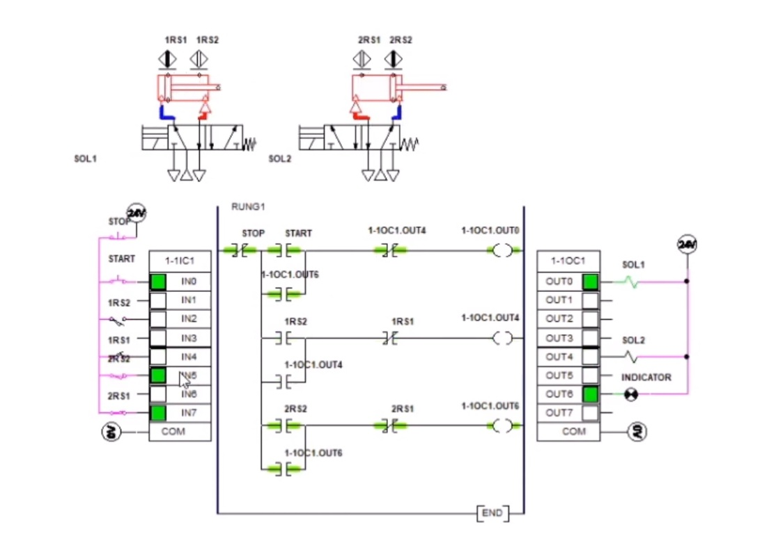

#_Theory:-
Programmable Logic Controllers (PLCs)

PLCs are specialized digital computers used for automation of industrial processes. They are designed to withstand harsh environments and can reliably control machines and processes through input/output (I/O) modules. PLCs read signals from sensors and switches, perform logic functions and control actuators based on a stored program. They offer flexibility, ease of programming and troubleshooting.
Ladder Logic Programming

Ladder logic programming is a graphical programming language used widely to program PLCs. It represents relay-based logic in a ladder diagram format resembling circuit schematics. Rungs contain normally open (NO) and normally closed (NC) contacts which are arranged in a series or parallel combinations to represent Boolean logic functions. Additional elements like timers, counters, math and comparators extend capabilities. Programs are developed and tested in automation studio software before downloading to PLCs.
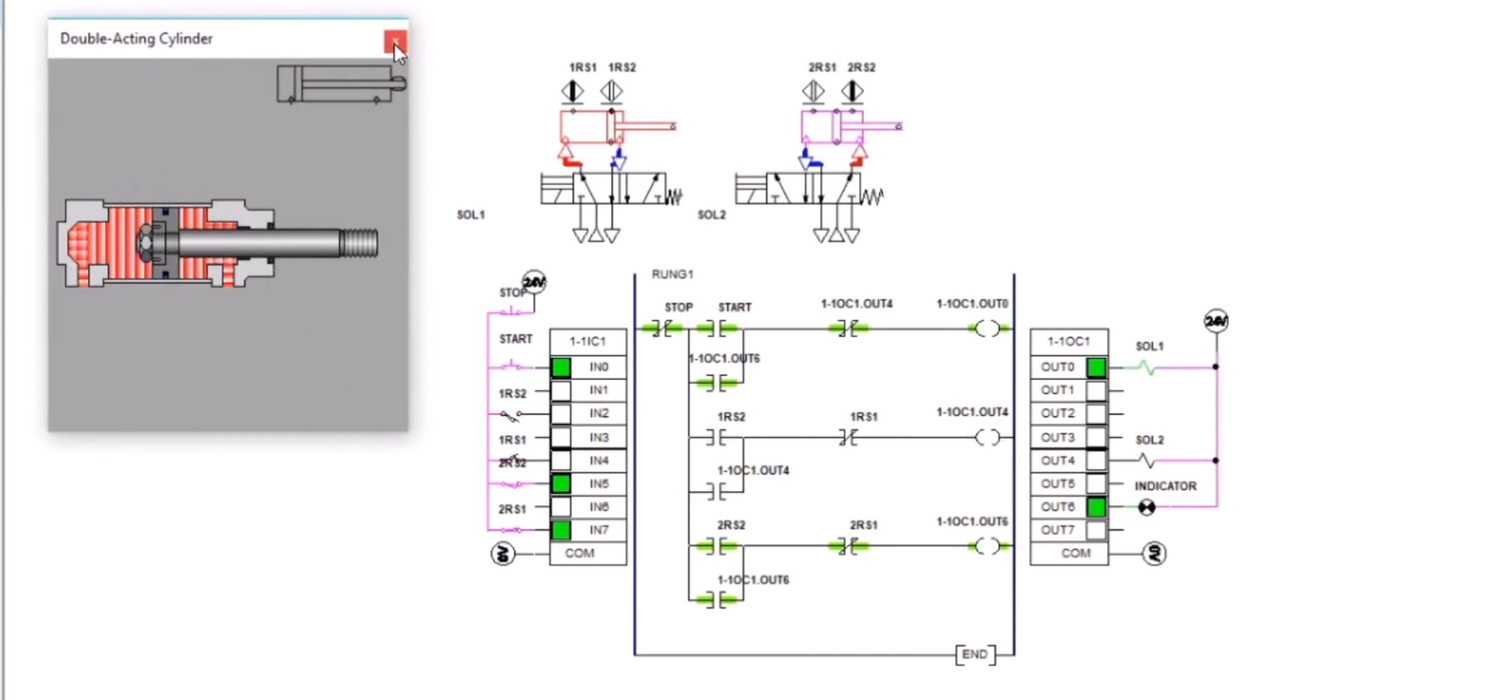

Electro-pneumatic Systems

These systems use air or other gases to actuate pneumatic components like cylinders, grippers, slides using control valves. Signals from sensors provide feedback on positions. Compressors provide air pressure which is regulated and distributed through solenoid valves. Cylinders provide linear or rotary motion to manipulate parts. Such low-cost systems are commonly used in material handling, packaging and assembly applications.
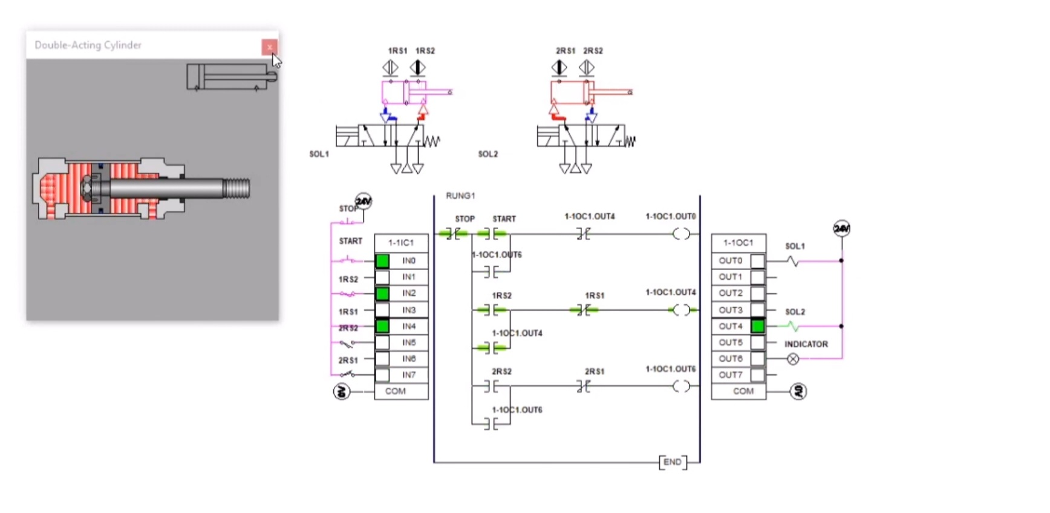

Automation Studio Software

Specialized software allows design of control programs in a virtual environment. Complete automation solutions involving PLCs, HMIs, drives, sensors etc. can be modeled, programmed and commissioned offline. Virtual commissioning eliminates errors and allows testing connectivity early. Programs can be directly deployed to physical controllers reducing commissioning time. Integrated simulators help validate ladder logic without hardware dependencies.
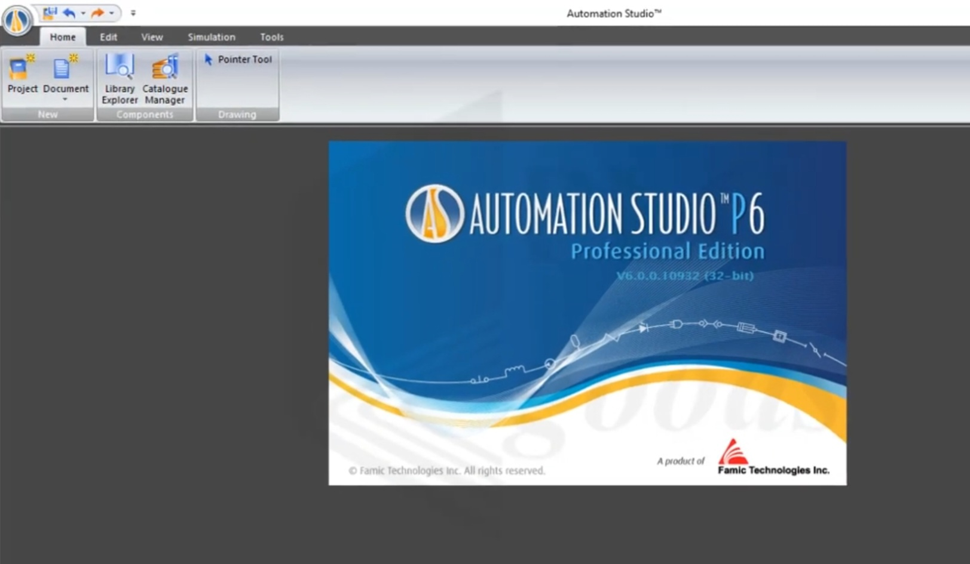

#_Methodology:-
The following steps were used to automate the electro-pneumatic system through ladder logic programming in the automation studio:

1. System Design Analysis
The first step involved understanding the design and operational requirements of the electro-pneumatic workcell. This included identifying all input and output devices, control elements, and sequences of operation. Preliminary diagrams and specifications were documented.

2. Simulation Environment Setup
The automation studio software was configured by importing the PLC programming device, I/O modules, sensors, actuators and HMIs required to model the system.

3. Ladder Logic Development
The sequences of operation were modeled using ladder logic elements like contacts, coils, timers and counters. Special functions were also incorporated for fault detection, indexed control etc.

4. Program Testing and Debugging
An iterative approach was used to thoroughly simulate and test the program. The logic was refined to eliminate errors with help of diagnostic tools.

5. Integration with Physical I/O
The PLC was connected to the actual input and output devices on site. End-to-end cycles were executed to validate field wiring and connections.

6. HMI Visualization
Operator screens for start/stop, monitoring parameters were created on the HMI to facilitate remote control and supervision.

7. Optimization and Documentation
The ladder code was optimized, annotated and documented. Drawings and manuals captured critical design information.

8. Downloading to PLC
The validated virtual program was transferred from the software to the PLC for automating real world operations.
9. Demonstration and Results
The successfully automated system was demonstrated along with results and conclusions.

#_The equipment:-
- Programmable Logic Controller (PLC): A [PLC model name] PLC was used to execute the ladder logic program and control the system. It contains input/output modules to interface with field devices.

- Pneumatic valves: [Number and types] of pneumatic valves such as 5/2 directional valves were used to control the direction of air flow to the cylinders. The valves are operated using signals from the PLC.

- Pneumatic cylinders: [Number and specifications] of double-acting cylinders such as 50mm bore diameter cylinders were used for lifting, gripping and positioning tasks.

- Air compressor: A [specifications] compressor supplied compressed air at [pressure] bar to the pneumatic circuit through a pressure regulator.

- Sensors: Proximity switches, limit switches etc. provided positional feedback to the PLC on cylinder movement and part presence.

- Solenoid valves: [Number and type] of solenoid valves like 3/2 valves were used to control the inlet ports of pneumatic valves electrically from the PLC outputs.

- HMI: A [model] HMI with a [size] touchscreen allowed operators to supervise and interact with the automated process.

- I/O modules: The PLC was fitted with appropriate digital and analog input/output modules to establish connections to the field devices and components.

- Pneumatic tubing: Air tubing was used to plumb the pneumatic valves, cylinders and other devices together to form the pneumatic circuit.

#_Discussion:-
This project demonstrated the successful development and implementation of a PLC ladder logic program to automate an electro-pneumatic system using an automation studio software package.

The virtual environment enabled thorough testing and debugging of the control program before deploying it to the physical system. Potential issues
were identified and resolved at the development stage through extensive simulations. This reduced commissioning time on site significantly.

Ladder logic provided an intuitive way to program the PLC to mimic the actual circuit diagrams and sequences of operations. Elements like timers, counters and math functions extended the capabilities. Programming best practices like modularization, comments and documentation facilitated program re-use and troubleshooting.

Integrating real world input-output reduced the gap between virtual and physical commissioning. End-to-end tests validated hardware wiring and coordination of electrical-pneumatic domains. This allowed confidence in the automated processes.

The HMI screens developed offered operator flexibility to start, stop and monitor processes remotely. Process data and alarms could be viewed for supervision.

The project established the effectiveness of programmable automation solutions using PLCs and programming environments. Virtual commissioning tools minimized risks while enhancing productivity, quality and safety. The automated electro-pneumatic system demonstrated precision, repeatability and reduced dependency on manual labor. With further enhancements, the integrated control system can drive advanced applications as well.

#_Conclusion:-
In conclusion, the objectives of automating an industrial process through PLC programming were successfully met with benefits of improved efficiency, flexibility and lesser commissioning efforts.

#_Reference:-In general, I used the sites provided in the Google and in a Chat gbt

